Step Debugging
Xdebug's step debugger allows you to interactively walk through your code to debug control flow and examine data structures.

Introduction
Xdebug interacts with IDEs to provide step debugging functionality, and therefore you also need to configure an IDE that knows how to talk to Xdebug with the open DBGp protocol.
This protocol is supported by nearly every PHP IDE (including Visual Studio Code and PhpStorm), and also by text-based editors. There is also a simple Command Line Debug Client available as part of the Xdebug project, but it is strongly recommended that you use an IDE for debugging. (An overview of third party clients is available further down this page.)

Configuring Step Debugging
In your php.ini, 90-xdebug.ini, or other distribution specific PHP ini file, change (or set) the xdebug.mode setting to debug. In set-ups where PHP/Xdebug and your IDE all run on the same host, this is all you need to configure on the PHP and Xdebug side. (Skip to Activating the Debugger if that's the case.)
If PHP/Xdebug run on a different machine, virtual host, or in a Docker container, you need to tell Xdebug where to make the debugging connection to, as it is Xdebug that initiates the communication to the IDE, and not the other way around.
If PHP/Xdebug run on a different machine in the same sub-net, and you run your browser on the same host as your IDE, then you set the xdebug.discover_client_host setting to 1. Xdebug will then use the HTTP headers to find out the IP address of the host that initiated the debugging request, and use that IP address to connect to. This is a common way of set-up if you are sharing a development server among you and your team mates.
In more complex set-ups you need to configure the host and port that Xdebug connects to yourself. With xdebug.client_host you can select the IP or hostname of the machine that runs your IDE, and with xdebug.client_port the TCP port. Make sure that the host running PHP/Xdebug can connect to your IDE with the configured IP address and port, and that there is no firewall or other software blocking an incoming connection.

Activating Step Debugging
In the default configuration, the debugger activates if a "trigger" is present, although it's possible to instruct the debugger to always initiate a debugging session by setting xdebug.start_with_request to yes.
Which trigger to use depends on whether you're debugging a PHP application through a browser, or on the command line, such as when running unit tests.

Command Line
To signal the debugger to initiate connections, Xdebug will look whether the XDEBUG_SESSION environment variable is present.
The value of the variable does not matter unless you have set up a trigger value with xdebug.trigger_value.
On Unix like platforms, you can set it like:
export XDEBUG_SESSION=1
On Windows, you set the environment like:
set XDEBUG_SESSION=1
When you now run a php script with php myscript.php or vendor/bin/phpunit Xdebug will initiate a debugging session and connect to your IDE.
Please refer to the Troubleshooting section if it does not seem like Xdebug is activating.

Browser Application
The recommended way to initiate a debugging session is by configuring your IDE to accept incoming debugging connections, and then use a browser extension which sets the right trigger cookie.

Browser Extension Initiation
The extensions are:
- Xdebug Helper for Firefox (source).
- Xdebug Helper for Chrome (source).
- XDebugToggle for Safari (source).
Each extension adds an icon to your browser where you can select which functionality you want to trigger. Xdebug will continue to start debugging for every request as long as the debug toggle has been enabled.

Manual Initiation
Alternatively, you can signal Xdebug to initiate debugging for a single request by adding XDEBUG_SESSION=session_name as additional GET (or POST) parameter.
For debugging multiple subsequent requests, Xdebug supports debugging sessions managed by a cookie.
Set the XDEBUG_SESSION_START=session_name GET (or POST) HTTP parameter. The value for session_name is not important.
Xdebug will set the XDEBUG_SESSION cookie. As long as the cookie is present, debugging will be initiated for every HTTP request (including favicons and images if they go through PHP).
The time-out of the cookie is one hour.
If you set the XDEBUG_SESSION_STOP GET (or POST) HTTP parameter, Xdebug removes the cookie.

Alternative Ways of Triggering the Debugger
There are other ways how debugger activation can be triggered.

By Calling xdebug_break()
Calling xdebug_break() will trigger a debugging connection as long as xdebug.start_with_request is set to trigger and no debugger session is active yet. If a debugger session is already active, it will simply act as if a breakpoint was set through your IDE.

Upon an Error Situation
If you set xdebug.start_upon_error to yes then Xdebug will trigger a debugging connection when a PHP Notice or Warning appears, or when a Throwable (Error or Exception) is thrown.

Troubleshooting
You can troubleshoot Xdebug's attempts at initiating debugging connections by configuring a log file through xdebug.remote_log. When the connection is successfully established the log will also contain the communication between Xdebug and IDE.
The log file will contain to which IP addresses it is attempting to connect and at which ports, which should be a great help debugging why it sometimes doesn't work. A "remote log file" is also required when reporting a bug in Xdebug's step debugger.
There are several logging levels which can be configured through xdebug.remote_log_level.
The xdebug.remote_log setting requires as argument a full path to a file, to which the user that PHP/Xdebug runs as can write to. It is advisable to use something like /tmp/xdebug.log.
Be aware: On many Linux distributions that run services through Systemd, the actual file path could be different, such as:
/tmp/systemd-private-80b2a71a8b9843c0b7c21b0d357e59cc-apache2.service-CN4RBr/xdebug.log

Debugging Clients
This is an incomplete list of third-party clients, both free and commercial. Please refer to the original authors of these tools for documentation and support:
- Eclipse plugin (IDE).
- KDevelop (IDE: Linux (KDE); Open Source).
- ActiveState's Komodo (IDE: Windows, Linux, Mac; Commercial).
- NetBeans (IDE: Windows, Linux, Mac OS X and Solaris).
- Devsense's PHP Tools for Visual Studio (Plugin; Commercial).
- JetBrains' PhpStorm (IDE; Commercial).
- SublimeTextXdebug (Plugin for Sublime Text 2 and 3, Open Source).
- VIM plugin (Plugin; Open Source).
- VS Code plugin (Plugin; Open Source).
The simple command line client dbgpClient for debugging is available on the download page.

Implementation Details
This section documents some implementation details, that are mostly useful for authors of debugging clients that interact with Xdebug.

DBGp: context_names
Xdebug's implementation of the DBGp protocol's context_names command does not depend on the stack level. The returned value is always the same during each debugger session, and hence, can be safely cached.

Custom DBGp commands
The DBGp protocol allows for debugger engine specific commands, prefixed with the xcmd_ prefix. Xdebug includes a few of these, and they're documented here.

DBGp: xcmd_profiler_name_get
If Xdebug's profiler is currently active (See: Profiling), this command returns the name of the file that is being used to write the profiling information to.

DBGp: xcmd_get_executable_lines
This command returns which lines in an active stack frame can have a working breakpoint. These are the lines which have an EXT_STMT opcode on them. This commands accepts a -d option, which indicates the stack depth, with 0 being the top leve stack frame.
The command returns the information in the following XML format:
<?xml version="1.0" encoding="iso-8859-1"?>
<response
xmlns="urn:debugger_protocol_v1"
xmlns:xdebug="https://xdebug.org/dbgp/xdebug"
command="xcmd_get_executable_lines"
transaction_id="10">
<xdebug:lines>
<xdebug:line lineno="2"></xdebug:line>
<xdebug:line lineno="3"></xdebug:line>
<xdebug:line lineno="4"></xdebug:line>
<xdebug:line lineno="6"></xdebug:line>
<xdebug:line lineno="8"></xdebug:line>
</xdebug:lines>
</response>

Related Settings and Functions
- string xdebug.client_discovery_header = ""
- string xdebug.client_host = localhost
- integer xdebug.client_port = 9003
- integer xdebug.connect_timeout_ms = 200
- boolean xdebug.discover_client_host = false
- string xdebug.idekey = *complex*
- string xdebug.log =
- integer xdebug.log_level = 7
- string xdebug.mode = develop
- string xdebug.start_upon_error = default
- string xdebug.start_with_request = default
- string xdebug.trigger_value = ""
- xdebug_break() : bool
- xdebug_info() : void
- xdebug_is_debugger_active() : bool

Settings

string xdebug.client_discovery_header = "" #
If xdebug.client_discovery_header is configured to be a non-empty string, then the value is used as key in the $_SERVER superglobal array to determine which header to use to find the IP address or hostname to use for 'connecting back to'. This setting is only used in combination with xdebug.discover_client_host and is otherwise ignored.
For example, if xdebug.client_discovery_header is set to FORWARD_HOST, then Xdebug will check $_SERVER['FORWARD_HOST'] before the $_SERVER['HTTP_X_FORWARDED_FOR'] and $_SERVER['REMOTE_ADDR'] variables.

string xdebug.client_host = localhost #
Configures the IP address or hostname where Xdebug will attempt to connect to when initiating a debugging connection. This address should be the address of the machine where your IDE or debugging client is listening for incoming debugging connections.
On non-Windows platforms, it is also possible to configure a Unix domain socket which is supported by only a select view debugging clients. In that case, instead of the hostname or IP address, use unix:///path/to/sock.
If xdebug.discover_client_host is enabled then Xdebug will only use the value of this setting in case Xdebug can not connect to an IDE using the information it obtained from HTTP headers. In that case, the value of this setting acts as a fallback only.
This setting can additionally be configured through the XDEBUG_CONFIG environment variable.

integer xdebug.client_port = 9003 #
The port to which Xdebug tries to connect on the remote host. Port 9003 is the default for both Xdebug and the Command Line Debug Client. As many clients use this port number, it is best to leave this setting unchanged.
This setting can additionally be configured through the XDEBUG_CONFIG environment variable.

integer xdebug.connect_timeout_ms = 200 #
The amount of time in milliseconds that Xdebug will wait for on an IDE to acknowledge an incoming debugging connection. The default value of 200 ms should in most cases be enough. In case you often get dropped debugging requests, perhaps because you have a high latency network, or a development box far away from your IDE, or have a slow firewall, then you can should increase this value.
Please note that increasing this value might mean that your requests seem to 'hang' in case Xdebug tries to establish a connection, but your IDE is not listening.

boolean xdebug.discover_client_host = false #
If enabled, Xdebug will first try to connect to the client that made the HTTP request. It checks the $_SERVER['HTTP_X_FORWARDED_FOR'] and $_SERVER['REMOTE_ADDR'] variables to find out which hostname or IP address to use.
If xdebug.client_discovery_header is configured, then the $_SERVER variable with that configured name will be checked before HTTP_X_FORWARDED_FOR and REMOTE_ADDR.
If Xdebug can not connect to a debugging client as found in one of the HTTP headers, it will fall back to the hostname or IP address as configured by the xdebug.client_host setting.
This setting does not apply for debugging through the CLI, as the $_SERVER header variables are not available there.
This setting can additionally be configured through the XDEBUG_CONFIG environment variable.
Warning: Please note that there is no filter available, and anybody who can connect to the webserver will then be able to start a debugging session, even if their address does not match xdebug.client_host.

string xdebug.idekey = *complex* #
Controls which IDE Key Xdebug should pass on to the debugging client or proxy. The IDE Key is only important for use with the DBGp Proxy Tool, although some IDEs are incorrectly picky as to what its value is.
The default is based on the DBGP_IDEKEY environment setting. If it is not present, the default falls back to an empty string.
If this setting is set to a non-empty string, it selects its value over DBGP_IDEKEY environment variable as default value.
The internal IDE Key also gets updated through debugging session management and overrides the value of this setting as is explained in the Step Debugging documentation.
This setting can additionally be configured through the XDEBUG_CONFIG environment variable.

string xdebug.log = #
Configures Xdebug's log file.
Xdebug will log to this file all file creations issues, Step Debugging connection attempts, failures, and debug communication.
Enable this functionality by setting the value to a absolute path. Make sure that the system user that PHP runs at (such as www-data if you are running with Apache) can create and write to the file.
The file is opened in append-mode, and will therefore not be overwritten by default. There is no concurrency protection available.
The log file will include any attempt that Xdebug makes to connect to an IDE:
[2693358] Log opened at 2020-09-02 07:19:09.616195
[2693358] [Step Debug] INFO: Connecting to configured address/port: localhost:9003.
[2693358] [Step Debug] ERR: Could not connect to debugging client. Tried: localhost:9003 (through xdebug.client_host/xdebug.client_port) :-(
[2693358] [Profiler] ERR: File '/foo/cachegrind.out.2693358' could not be opened.
[2693358] [Profiler] WARN: /foo: No such file or directory
[2693358] [Tracing] ERR: File '/foo/trace.1485761369' could not be opened.
[2693358] [Tracing] WARN: /foo: No such file or directory
[2693358] Log closed at 2020-09-02 07:19:09.617510
It includes the opening time (2020-09-02 07:19:09.616195), the IP/Hostname and port Xdebug is trying to connect to (localhost:9003), and whether it succeeded (Connected to client :-)). The number in brackets ([2693358]) is the Process ID.
It includes:
[2693358]
process ID in brackets
2020-09-02 07:19:09.616195
opening time
For Step Debugging:
INFO: Connecting to configured address/port: localhost:9003.
ERR: Could not connect to debugging client. Tried: localhost:9003 (through xdebug.client_host/xdebug.client_port) :-(
For Profiling:
ERR: File '/foo/cachegrind.out.2693358' could not be opened.
WARN: /foo: No such file or directory
For Function Trace:
ERR: File '/foo/trace.1485761369' could not be opened.
WARN: /foo: No such file or directory
All warnings and errors are described on the Description of errors page, with detailed instructions on how to resolve the problem, if possible. All errors are always logged through PHP's internal logging mechanism (configured with error_log in php.ini). All warnings and errors also show up in the diagnostics log that you can view by calling xdebug_info().

Step Debugger Communication
The debugging log can also log the communication between Xdebug and an IDE. This communication is in XML, and starts with the <init XML element:
<init
xmlns="urn:debugger_protocol_v1" xmlns:xdebug="https://xdebug.org/dbgp/xdebug"
fileuri="file:///home/httpd/www.xdebug.org/html/router.php"
language="PHP" xdebug:language_version="7.4.11-dev"
protocol_version="1.0" appid="2693358" idekey="XDEBUG_ECLIPSE">
<engine version="3.0.0-dev"><![CDATA[Xdebug]]></engine>
<author><![CDATA[Derick Rethans]]></author>
<url><![CDATA[https://xdebug.org]]></url>
<copyright><![CDATA[Copyright (c) 2002-2020 by Derick Rethans]]></copyright>
</init>
The fileuri attribute lists the entry point of your application, which can be useful to compare to breakpoint_set commands to see if path mappings are set-up correctly.
Beyond the <init element, you will find the configuration of features:
<- feature_set -i 4 -n extended_properties -v 1
-> <response
xmlns="urn:debugger_protocol_v1" xmlns:xdebug="https://xdebug.org/dbgp/xdebug"
command="feature_set" transaction_id="4" feature="extended_properties" success="1">
</response>
And continuation commands:
<- step_into -i 9
-> <response
xmlns="urn:debugger_protocol_v1" xmlns:xdebug="https://xdebug.org/dbgp/xdebug"
command="step_into" transaction_id="9"
status="break" reason="ok">
<xdebug:message filename="file:///home/httpd/www.xdebug.org/html/router.php" lineno="3">
</xdebug:message>
</response>
You can read about DBGP - A common debugger protocol specification at its dedicated documation page.
The xdebug.log_level setting controls how much information is logged.
Note: Many Linux distributions now use systemd, which implements private tmp directories. This means that when PHP is run through a web server or as PHP-FPM, the /tmp directory is prefixed with something akin to:
/tmp/systemd-private-ea3cfa882b4e478993e1994033fc5feb-apache.service-FfWZRg
This setting can additionally be configured through the XDEBUG_CONFIG environment variable.

integer xdebug.log_level = 7 #
Configures which logging messages should be emitted.
The following levels are supported:
Level | Name | Example
1 | Errors | Connection errors
3 | Warnings | Connection warnings
5 | Communication | Protocol messages
7 | Information | Information while connecting
10 | Debug | Breakpoint resolving information
Errors are also logged through PHP's internal logging mechanism (configured with error_log in php.ini).
Warnings and errors show up in the diagnostics log that you can view by calling xdebug_info().
This setting can additionally be configured through the XDEBUG_CONFIG environment variable.

string xdebug.mode = develop #
This setting controls which Xdebug features are enabled.
This setting can only be set in php.ini or files like 99-xdebug.ini that are read when a PHP process starts (directly, or through php-fpm), but not in .htaccess and .user.ini files where are read per-request.
The following values are accepted:
off
Nothing is enabled. Xdebug does no work besides checking whether functionality is enabled. Use this setting if you want close to 0 overhead.
develop
Enables Development Aids including the overloaded var_dump().
coverage
Enables Code Coverage Analysis to generate code coverage reports, mainly in combination with PHPUnit.
debug
Enables Step Debugging. This can be used to step through your code while it is running, and analyse values of variables.
gcstats
Enables Garbage Collection Statistics to collect statistics about PHP's Garbage Collection Mechanism.
profile
Enables Profiling, with which you can analyse performance bottlenecks with tools like KCacheGrind.
trace
Enables the Function Trace feature, which allows you record every function call, including arguments, variable assignment, and return value that is made during a request to a file.
You can enable multiple modes at the same time by comma separating their identifiers as value to xdebug.mode: xdebug.mode=develop,trace.
You can also set the mode by setting the XDEBUG_MODE environment variable on the command-line; this will take precedence over the xdebug.mode setting.

string xdebug.start_upon_error = default #
Step Debugging can be activated when a PHP Notice or Warning is emitted, or when a Throwable (Exception/Error) is thrown, depending on the value of this setting:
yes
Initialise a debugging session when a PHP Notice or Warning is emitted, or when a Throwable is thrown.
no
default
Do not start a debugging session upon an error situation.
This setting is independent of xdebug.start_with_request, and therefore it is not necessary to set xdebug.start_with_request=trigger.

string xdebug.start_with_request = default #
A Function Trace, Garbage Collection Statistics, Profiling, or Step Debugging can be activated at the start of a PHP request. Whether this happens depends on the value of this setting:
yes
The functionality starts when the PHP request starts, and before any PHP code is run.
For example xdebug.mode=trace and xdebug.start_with_request=yes starts a Function Trace for the whole request.
no
The functionality does not get activated when the request starts.
You can still start a Function Trace with xdebug_start_trace(), Step Debugging with xdebug_break(), or Garbage Collection Statistics with xdebug_start_gcstats().
trigger
The functionality only gets activated when a specific trigger is present when the request starts.
The name of the trigger is XDEBUG_TRIGGER, and Xdebug checks for its presence in either $_ENV (environment variable), $_GET or $_POST variable, or $_COOKIE (HTTP cookie name).
There is also a legacy fallback to a functionality specific trigger name: XDEBUG_PROFILE (for Profiling), XDEBUG_TRACE (for a Function Trace), and XDEBUG_SESSION (for Step Debugging).
Debug session management for Step Debugging is also available through XDEBUG_SESSION_START.
With xdebug.trigger_value you can control which specific trigger value will activate the trigger. If xdebug.trigger_value is set to an empty string, any value will be accepted.
default
The default value depends on xdebug.mode:
- debug: trigger
- gcstats: no
- profile: yes
- trace: trigger

string xdebug.trigger_value = "" #
This setting can be used when xdebug.start_with_request is set to trigger, which is the default for Step Debugging and Function Trace.
In trigger mode, Xdebug will only start its functionality when the XDEBUG_TRIGGER is set in the environment, or when the XDEBUG_TRIGGER GET, POST, or COOKIE variable is set.
Normally, Xdebug does not look at which value is actually used. If this setting is set to a non-empty string, then Xdebug will only trigger if the value matches the value of this setting.
With the following settings:
xdebug.mode=profile
xdebug.start_with_request=trigger
xdebug.trigger_value=StartProfileForMe
Xdebug's profiler will only start when either the environment variable XDEBUG_TRIGGER is set to StartProfileForMe, the GET or POST variable XDEBUG_TRIGGER is set to StartProfileForMe, or when the cookie XDEBUG_TRIGGER has the value StartProfileForMe.
See also:
xdebug.start_with_request#trigger
For how the triggering mechanism works, and which environment and server variables Xdebug acts on.

Functions

xdebug_break() : bool #
Emits a breakpoint to the debug client
This function makes the debugger break on the line it is called from, as if a normal file/line breakpoint was set on this line through the debugger protocol.
If no debugging session is active yet, and xdebug.start_upon_request is set to trigger, then Xdebug will attempt to start a new debugging session first.
The function returns true if a debugging session is (now) active, and the breakpoint was succesfully set. It returns false if a debugging session was not active and could not be activated.

xdebug_info() : void #
Show diagnostic information
This function returns an HTML page which shows diagnostic information. It is analogous to PHP's phpinfo() function.
The HTML output includes which mode is active, what the settings are, and diagnostic information in case there are problems with debugging connections, opening of files, etc.
Each warning and error in the diagnostics log also links through to the Description of errors documentation page.
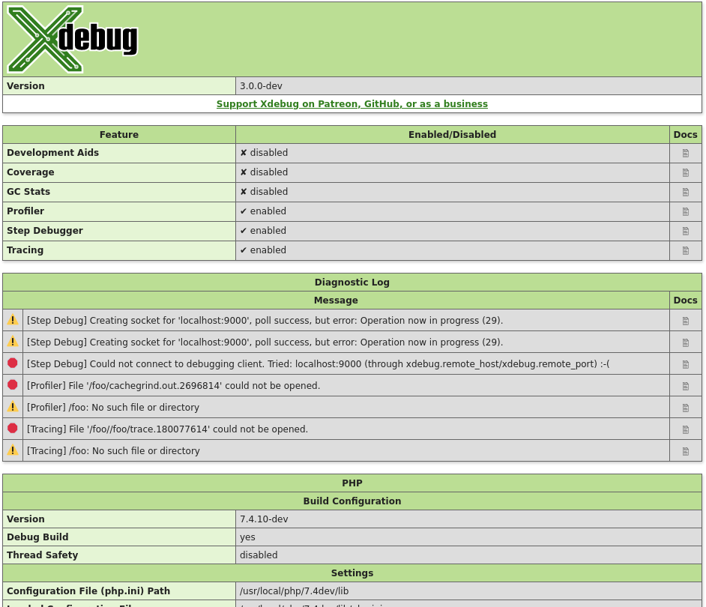

xdebug_is_debugger_active() : bool #
Returns whether a debugging session is active
Returns true if a debugging session through DBGp is currently active with a client attached; false, if not.
https://xdebug.org/docs/step_debug

